FBLA Car Show
November 9, 2019
10:00 am to 2:00 pm
Set Up Beginning at 8:00 am
Franklin High School Parking Lot
100 Panther Drive
Franklin, NC 28734

Cash and/or Trophy Prizes awarded: Appalachian Rescue
People’s Choice Adoption Opportunity
Best in Class Late Model 10:00 am-2:00 pm
Best in Class Modern Dog/Cat Food Donations Accepted
And more…
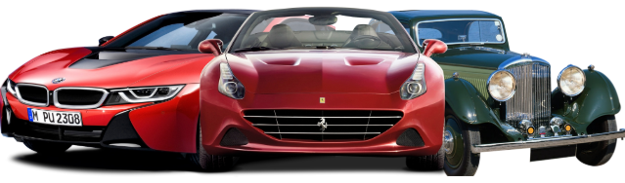

Entry Information
Advanced Registration Fee $25.00
Day of the Show $35.00
Return to Michelle Brooks at Franklin High School or call (828)421-2850

Name _________________________________________________________________

Contact Number _________________________________________________________________

Email Address _________________________________________________________________

Mailing Address _________________________________________________________________

Make _________________________________________________________________

Model _________________________________________________________________

Year _________________________________________________________________

Proceeds to benefit:
The FBLA Scholarship
The Walter Wright Memorial Scholarship
Appalachian Animal Rescue

